BAPTISM RENEWAL
10:00 am - This first Sunday of the calendar year, come forward to the baptismal font, receive a blessing and renew your baptismal commitment to be a follower of Christ.

ASH WEDNESDAY
7:00 pm - The 40-day journey of Lent begins with the imposition of ashes. Prepare for Easter during this time by fasting, repentance, moderation and spiritual discipline.

UMCOR SUNDAY
10:00 am - A special offering is taken for the United Methodist Committee on Relief. UMCOR provides outreach and disaster relief in more than 115 countries.

HOLY THURSDAY
6:00 pm - We commemorate the Last Supper with a free community dinner and service of communion at our Harmont location (3412 Harmont Ave NE).

GOOD FRIDAY
2
7:00 pm - Observe the solemn occasion of Good Friday with a traditional service in the sanctuary.

EASTER
10:00 am - The Lord is risen indeed! Celebrate Jesus’ resurrection with a festive service in our flower-filled historic downtown sanctuary. Care for infant to 6th grade is provided.

NEW BEGINNINGS CLASS
11:00 am - Spend an hour each week after our in-person worship in this small group led by our Pastors to take your first or your next steps along Christ’s path.

DAY OF KINDNESS/NEIGHBORHOOD SERVICE DAY/BBQ
1:00 pm - We put our prayers to work in the greater Shorb neighborhood by planting flowers and celebrating kindness. Then, we barbecue.

PENTECOST
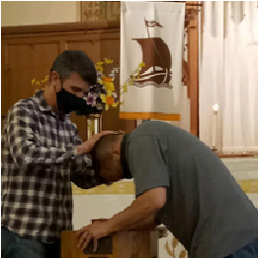
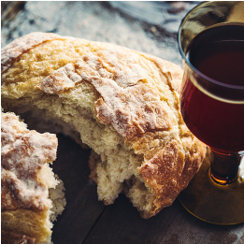
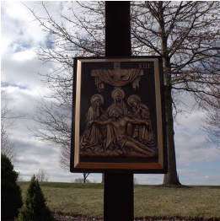
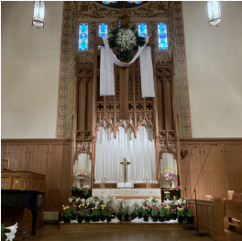
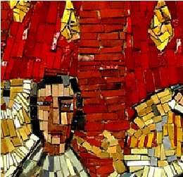
10:00 am - Pentecost is the birthday of the church, the day the disciples received the Holy Spirit. We celebrate with a festive service in our historic downtown sanctuary.
E
P
I
P
H
A
N
Y
Cleveland Ave SW
120

Canton, Ohio 44702
330-455-0153
cantonforallpeople.org

24
J
a
n
u
a
r
y
F
e
b
r
u
a
r
y
A
p
r
i
l
7
E
A
S
T
E
R
L
E
N
T
Crossroads United Methodist Church

CALENDAR
M
a
r
c
h
14
10
28
29
31
7
M
a
y
11
P
E
N
T
E
C
O
S
T
19

ALDERSGATE WORSHIP
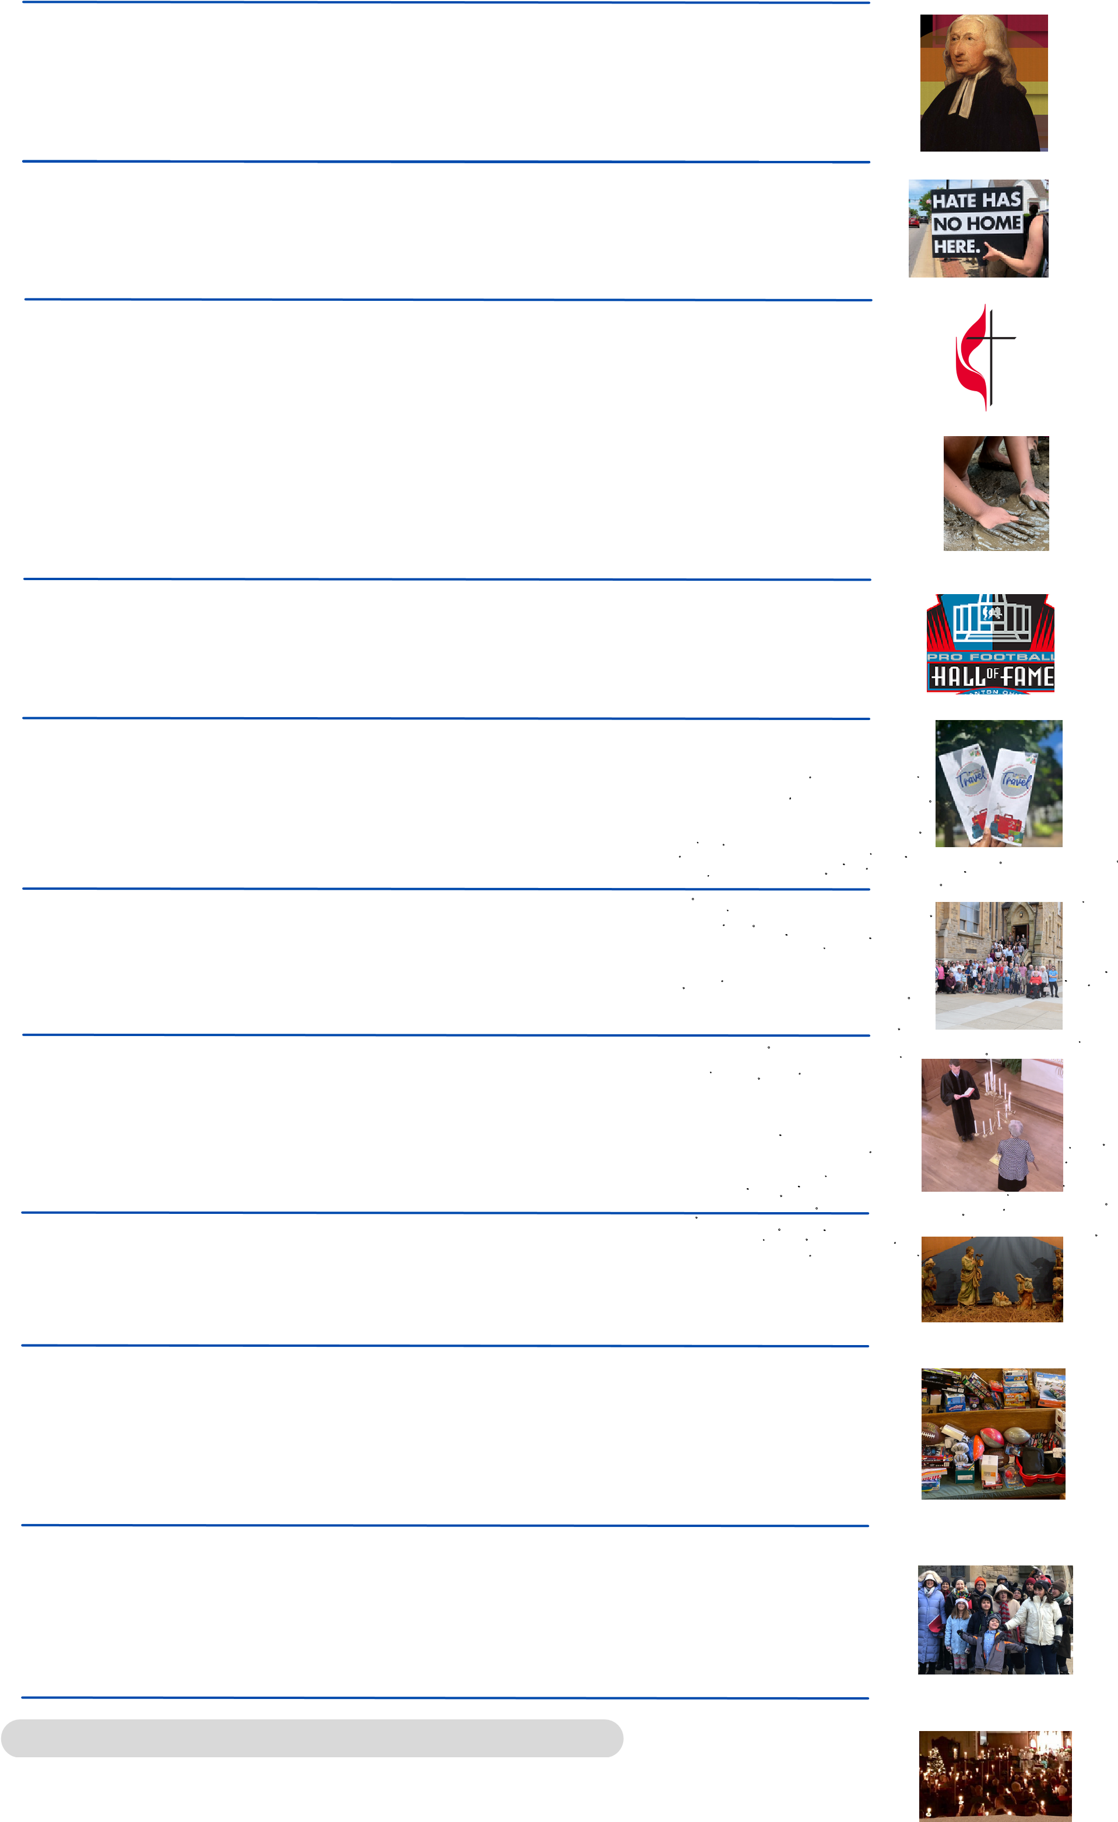
24 7:00 pm - All Methodists are welcome to this special Friday evening celebration where we link our heritage and history with our present and future. A reception follows in Wesley hall.

PEACE WITH JUSTICE SUNDAY
26 1:00 pm - Gather outside the church to pray for peace and justice in our community before a seven-mile walk northwards on Cleveland Ave.

EAST OHIO ANNUAL CONFERENCE
13 Our delegates attend this District’s annual gathering of clergy and laity.

INTERNATIONAL MUD DAY
29 eighth day, God made mud)! Bring extra clothes to our Harmont Noon - A one-day Vacation Bible School like no other (and on the location for this can’t-miss event!

HALL OF FAME YOUTH OVERNIGHT
All tweens and teens are invited for dinner, games and a movie at the church the night before the big HOF parade.
2

SHORB NEIGHBORHOOD BLOCK PARTY
10 community fellowship at our third annual block party. Kids, bring your Noo n - Enjoy games for all ages, international food, music, and bathing suits for water fun!
P  E  N  T  E  C  O  S  T | M  a  y
O  R  D  I  N  A  R  Y  T  I  M  E | J  u  n  e
A
u
g
u
s
t
S
e
p
t
e
m
b
e
r
N
o
v
e
m
b
e
r
A  D  V  E  N  T | D  e  c  e  m  b  e  r
C
H
R
I
S
T
M
A
S

CHURCH PICTURE DAY
11:00 am - Be in our annual church picture! There’s no dress code, but we do have a strict smile requirement!
8

ALL SAINTS‘ SUNDAY
10:00 am - On this special day, we remember and honor all of the beloved saints in our lives who rest from their labors. Bring a picture of your loved ones with you to enhance our remembrance.
3

HANGING OF THE GREENS
24 11:00 am - Plan to stay after worship to help decorate the sanctuary and other areas of the church for Advent and Christmas.
NEIGHBORHOOD CHRISTMAS SHOP 14 toys (ages 2 - 14) for children in the 44703 area. We need toy
11:00 am - Our second annual Christmas shop will once again provide donations and volunteers!

CAROLING
15 Canton neighborhoods. An award-winning singing voice is not required, 3:00 pm - Help spread seasonal cheer in some of our downtown but warm clothing usually is.
CHRISTMAS EVE CANDLELIGHT WORSHIP 24 highlight of every year, with festive music, candles and families filling
5:00 pm - Christ the Savior is born! This special evening service is a
the sanctuary.

